# Brainstorm

**TIP**

You can select a sticky note and hit the pencil [switch to sketch] icon to start drawing!

#### Before you collaborate

A little bit of preparation goes a long way with this session. Here’s what you need to do to get going.

**10 minutes**

**1**

#### Define your problem statement

What problem are you trying to solve? Frame your problem as a How Might We statement. This will be the focus of your brainstorm.

**5 minutes**

**2**

#### Brainstorm

Write down any ideas that come to mind that address your problem statement.

**10 minutes**

**3**

#### Group ideas

Take turns sharing your ideas while clustering similar or related notes as you go. In the last 10 minutes, give each cluster a sentence-like label. If a cluster is bigger than six sticky notes, try and see if you and break it up into smaller sub-groups.

**20 minutes**

**4**

#### Prioritize

Your team should all be on the same page about what's important moving forward. Place your ideas on this grid to determine which ideas are important and which are feasible.

**20 minutes**

#### After you collaborate

You can export the mural as an image or pdf to share with members of your company who might find it helpful.

**Quick add-ons**

# & idea prioritization

|  |  |  |  |  |  |  |
| --- | --- | --- | --- | --- | --- | --- |
|  | | | | | | |
|  |  | Quick response | More Languages | Step by step usage of guide and FAQs are provided | Understood by normal people |  |
|  |  |  |  | Update must be available |  |
| collect more datasets |  | Create application using python |
|  |  |  | Analyze the accuracy of the digits | Should consume less storage | App must suport in every Platforms (IOS/ Andriod) |
| Using more libraries | Create Gul to predict digits |  |  |  | Usage of more datasets to train the model |
|  |  | eir ere on  r can ing  ng the  d. |  |  |  |
|  | **TIP** |
| Latency issues leads to problems | Participants can use th cursors to point at wh sticky notes should go the grid. The facilitato confirm the spot by us the laser pointer holdi **H key** on the keyboar |
| Special adaptive hardware and software translate morse code into a form that computers understand so that standard software can be used | Provide personalized learning experiences tailored to the specific needs of students with disabilities | Algorithm creation leads to high cost |  |  |  |

**A Team gathering**

Define who should participate in the session and send an

**MYTHILI S**



**TIP**

Add customizable tags to sticky notes to make it easier to find, browse, organize, and categorize important ideas as themes within your mural.

**MONICA P**

Numby, Pandas, libraries

KAVIYA R K

LAVANYA M

**A Share the mural**

invite. Share relevant information or pre-work ahead.

Analyze the accuracy of the digit

Offline and compatible

Application which is easy to use

Create application

Import libraries

Making a major

Create an

application Using more

Application

Interface

Update

collect

App must suport in every

Model must be trained

**FEATURES**

**DATASETS**

**Share a view link** to the mural with stakeholders to keep

using

**PROBLEM**

**How might we [your problem statement]?**

difference in

using

libraries

which is

should be

must be

more

Platforms (IOS/ numerous times

### Use this template in your own

**Set the goal**

python

Latency

and load dataset

their ability

Special adaptive hardware and software translate morse code into a form that computers understand so that standard software can be used

python

Provide personalized

Evaluate

easy to use

flexible

available

Usage of

datasets

Step by step

Andriod)

Evaluate the model

Model must be trained numerous times to increase accuracy

Response

to increase accuracy

Must be

them in the loop about the outcomes of the session.

### brainstorming sessions so your team **B**

issues

Train the

Evaluate

learning experiences

More

Offline and more datasets

usage of guide

understandable

### can unleash their imagination and start shaping concepts even if you're not sitting in the same room.

**10 minutes** to prepare

**1 hour** to collaborate

**2-8 people** recommended

Think about the problem you'll be focusing on solving in the brainstorming session.

**C Learn how to use the facilitation tools**

Use the Facilitation Superpowers to run a happy and productive session.

[**Open article**](https://support.mural.co/en/articles/2113740-facilitation-superpowers)

#### Key rules of brainstorming

To run an smooth and productive session

leads to problems

Create Gul

to predict digits

**Person 5**

|  |  |  |
| --- | --- | --- |
|  |  |  |
|  |  |
|  |  |  |

model

Analyze the accuracy of the digits

the model

Understood by normal people

tailored to the specific needs of students with disabilities

provides another option

Speech input Analyze the

**Person 6**

|  |  |  |
| --- | --- | --- |
|  |  |  |
|  |  |
|  |  |  |

and train the model

accuracy of the digit

Languages

Quick response

**Person 7**

|  |  |  |
| --- | --- | --- |
|  |  |  |
|  |  |
|  |  |  |

compatible

Should

consume less storage

to train the model

Create GUI

to predict guests

and FAQs are provided

More time

needed to develop the application

**Person 8**

|  |  |  |
| --- | --- | --- |
|  |  |  |
|  |  |
|  |  |  |

must be immediate

A daily

notification must be send Inorder to intimate the daily activities

by normal peoples

Do not Buffer

and must be easy to install

Quick response

More Languages

Easy Interface

**PROGRAMMING ASPECTS**

So that Normal people can easily understand

collect more datasets

## 

Using more libraries

Create an application using python

App must suport in every Platforms (IOS/ Andriod)

**USER EXPECTATIONS**

## 

Should consume less storage

Step by step usage of guide and FAQs are provided

Response must be immediate

Update must be available

A daily notification must be send Inorder to intimate the daily activities

**B Export the mural**

Export a copy of the mural as a PNG or PDF to attach to emails, include in slides, or save in your drive.

#### Keep moving forward

**Strategy blueprint**

Define the components of a new idea or strategy.

[**Open the template**](https://app.mural.co/template/e95f612a-f72a-4772-bc48-545aaa04e0c9/984865a6-0a96-4472-a48d-47639307b3ca)

**Customer experience journey map**

Understand customer needs, motivations, and

Stay in topic. Defer judgment.

Encourage wild ideas. Listen to others.

#### Importance

If each of these

obstacles for an experience.

[**Open the template**](https://app.mural.co/template/b7114010-3a67-4d63-a51d-6f2cedc9633f/c1b465ab-57af-4624-8faf-ebb312edc0eb)

[**Share template feedback**](https://muralco.typeform.com/to/CiqaHVat?typeform-source=app.mural.co)

Go for volume. If possible, be visual.

tasks could get

done without any difficulty or cost, which would have the most positive impact?

## 

#### Feasibility

Regardless of their importance, which tasks are more feasible than others? (Cost, time, effort, complexity, etc.)

**Strengths, weaknesses, opportunities & threats**

Identify strengths, weaknesses, opportunities, and threats (SWOT) to develop a plan.

[**Open the template**](https://app.mural.co/template/6a062671-89ee-4b76-9409-2603d8b098be/ca270343-1d54-4952-9d8c-fbc303ffd0f2)

[**Share template feedback**](https://muralco.typeform.com/to/CiqaHVat?typeform-source=app.mural.co)

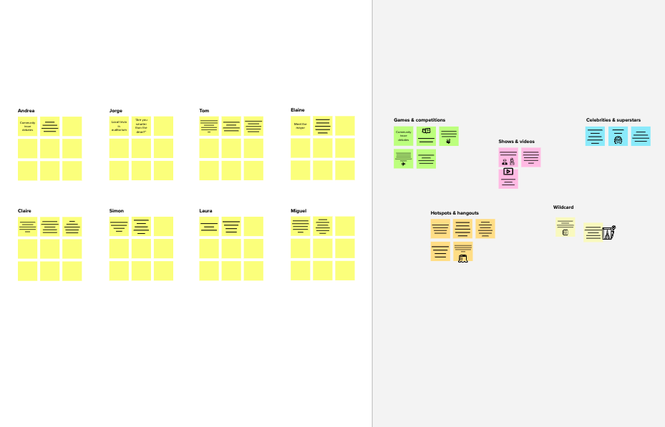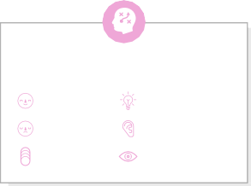

**Template**

**Need some inspiration?**

See a finished version of this template to kickstart your work.

[**Open example**](https://app.mural.co/template/e5a93b7b-49f2-48c9-afd7-a635d860eba6/93f1b98d-b2d2-4695-8e85-7e9c0d2fd9b9)